220 pairing script

This script automates the process found in this document>

<https://www.lifesize.com/en/help/admin-console/manage-room-systems/pair/220>

This script requires Putty to be installed on your Windows machine in addition to the requirements listed in the above page. The Windows machine running this script needs port 22 (SSH) access to the 220 device.

1. Throw the script on a machine in the customer’s environment. Please note there is a separate script for Express 220 units.
2. Run the script by double-clicking on the file; or right-click to ‘run as administrator’
3. You’ll need to manually key in four parameters into the subsequent command-line prompt

* IP address: - the ip address of the 220 unit.
* SSH password: - the SSH password for your 220 unit (defaults to ‘lifesize’)
* SIP Username: - This is the extension the 220 unit previously held.
* Authorization Password: - This is the password that’s auto-generated by the process outlined here

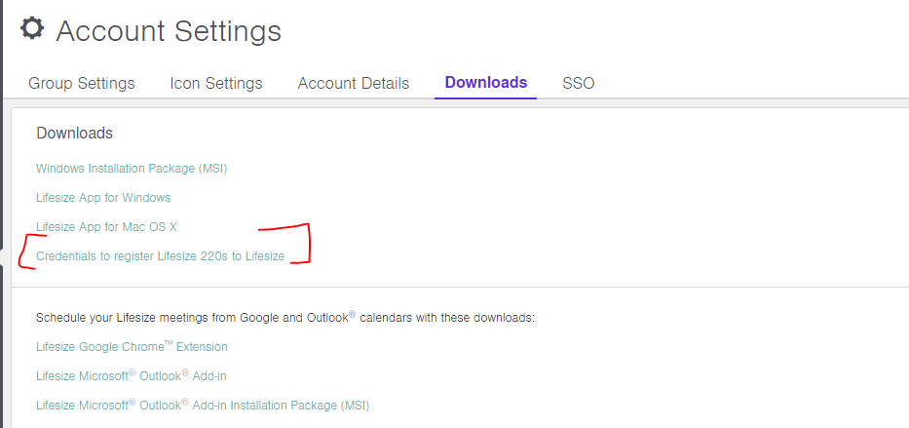

Example of a successful run:



The system should reboot and come back up.

Things to do to verify if the script worked:

>place a test call, receive a test call. *Please note: If you’re dialing from a CSS endpoint to the Galaxy 220 you’ll need to do <extension>@sip.lifesizecloud.com until they merge the two. Galaxy to Galaxy calls you only dial the extension.

>verify LDAP populates.

1. Finally, we still need to manually disable BFCP from the web interface.
   1. Open a browser and enter the IP address shown on your 220 *<IP address of 220>/support*
   2. Enter the **Username**and **Password**. The default login is *cli / lifesize*. Click **Sign in**.
   3. On the Advanced Comm Settings, click **Go To**.
   4. Set **BFCP is enabled** to **Disabled**.